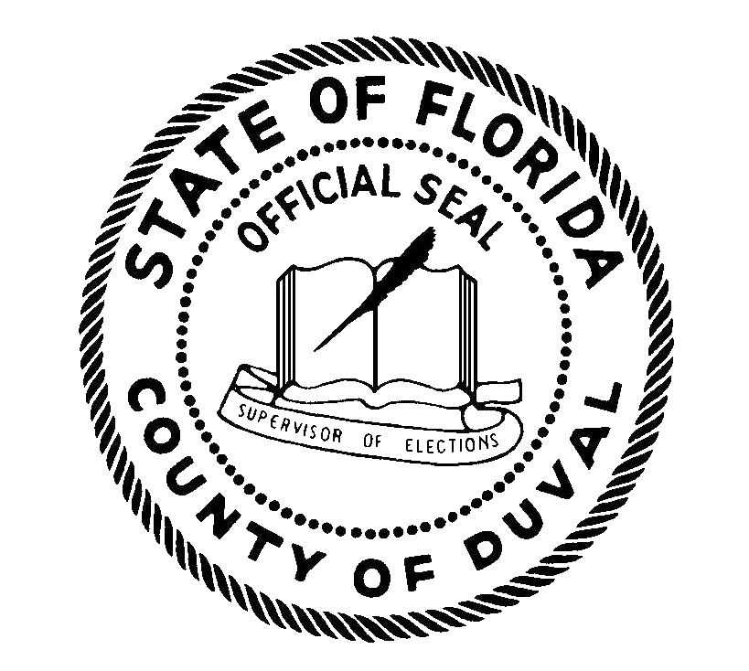 | Duval County Supervisor of Elections  2024 POLITICAL PARTY  PRECINCT/STATE  COMMITTEEMEN AND  COMMITTEEWOMEN
Election Date: | August 20, 2024
Term Begins: | December 1, 2024
Qualifications: | Registered voter of the respective political party in Duval County  Resident of the precinct from which elected
Term of Office: | 4 years
Electorate: | Registered voters of the respective political party and precinct
Qualifying Period: | Noon, June 10, 2024 thru Noon, June 14, 2024
Filing for Office | A membership loyalty oath / application may be required as part of qualifying for these positions. Please contact the county executive committee and / or state party for any additional party eligibility requirements to qualify or hold the office.
Local County and  State Political Party  Contact Information | Duval County Democratic Executive Committee  PO Box 2940  Jacksonville FL 32203  (904) 390-7001  https://www.duvaldems.org/  Florida Democratic Party  214 South Bronough Street  Tallahassee, FL 32301  (850) 222-3411  https://www.floridadems.org/  Duval County Republican Executive Committee  3520 St. Johns Bluff Rd. S., #3  Jacksonville, FL 32224  (904) 396-4233  https://duval.gop/  Republican Party of Florida  P.O. Box 311  Tallahassee, FL 32301  (850) 222-7920  https://florida.gop/
Campaign Finance and  Qualifying Forms: | A campaign treasurer’s report is required to be filed with the SOE on August 16, 2024, if receiving contributions or making expenditures  Notarized DS-DE 305CM Candidate Oath – Committeemen and Committeewomen

This document is being provided for informational purposes only and does not constitute legal advice. It is recommended that candidates consult legal counsel or professional advisors, as the candidate is responsible for following Florida Election Law, local charters and regulations relating to their campaign or qualifications to seek office.

